ZERO

Technical Documentation

JuFeng Li

2020 .6

目录

1 character control 4

1.1 Animation State Machine 4

1.2 move control 7

1.2.1move jump and air condition 7

1.2.1move control 7

1.3 attack control 9

1.3.1 normal attack andcombo 9

1.3.2 cast abilities 9

1.3.3 CD control 10

1.3.4 attack detection 10

1.4 target choose 12

2 Attribute management 14

2.1 attribute types 14

2.2 damage control 14

2.3 kill and death broadcast 15

3 weapon management 16

3.1 weapon swtich 17

3.2 weapon acquire 18

4 state control 19

4.1 state types 19

4.2 state process 19

5 skills 20

5.1 normal attack of weapons 20

5.2 weapon skills 21

5.3 common skills 24

5.4 backpack 27

5.5 effects production 27

6 secene management 33

6.1 props control 33

6.2 circle control 34

6.3 character birth place 35

7 time synchronization 35

7.1 game time 35

7.2 circle time 36

8 data 36

8.1 data synchronization 36

9 UI design and implementation 36

9.1 lobby 37

9.1.1 login and register 37

9.1.2 room window 38

9.1.3 create room 39

9.1.4 record window 39

9.1.5 setting window 40

9.1.5 interface background 40

9.1.6 loading interface 41

9.2 game interface 42

9.2.1 skill window and backpack 42

9.2.2 attribute interface 42

9.2.3 tips top on head 43

9.2.4 light circle underfoot 44

9.2.5 ranking list 44

9.2.6 tip 45

9.2.7 time, frame count and minimap in upper right corner 46

9.2.6 evaluating interface 46

# Character conrtol

1. Animation state machine

Animator Controller: 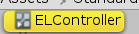

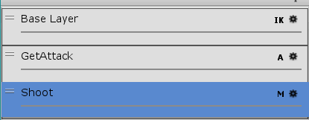 BaseLayer

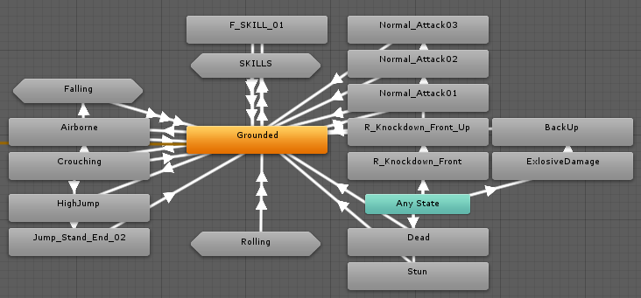

roll

Under attack

combo

Weapon skill

jump

Main factors Float controlling move

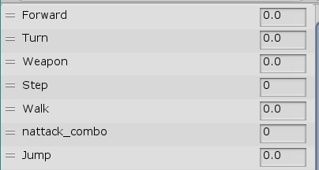

jump，the value for rigidbody.velocity

combo，0 1 2 3

Factors of weapons，0 1 2 3 4 5

Right or left，-1-1

Head or back，-1-1

Falling

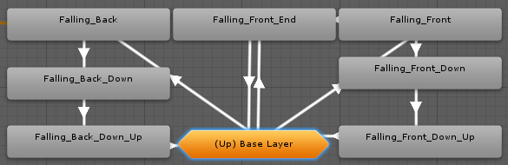

A fall is either a forward fall or a backward fall，

Airborne Blend Tree

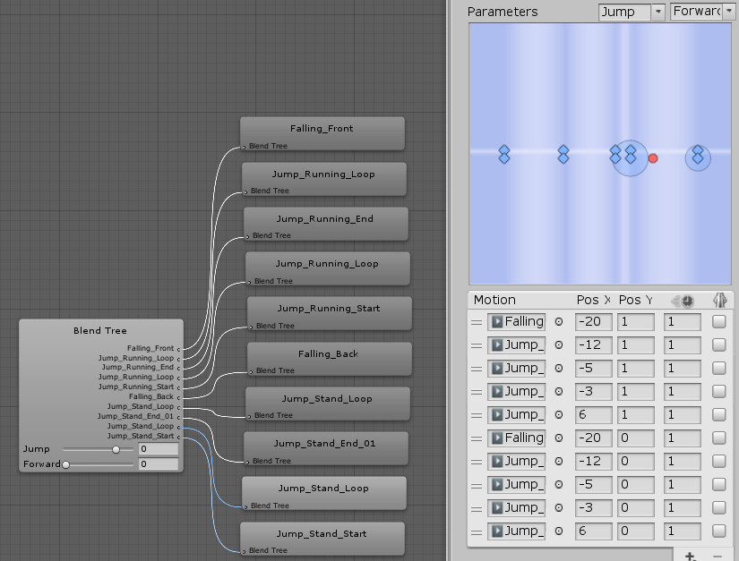

Skills :each weapon owns 3 skills

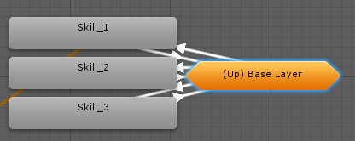

Skill blend tree

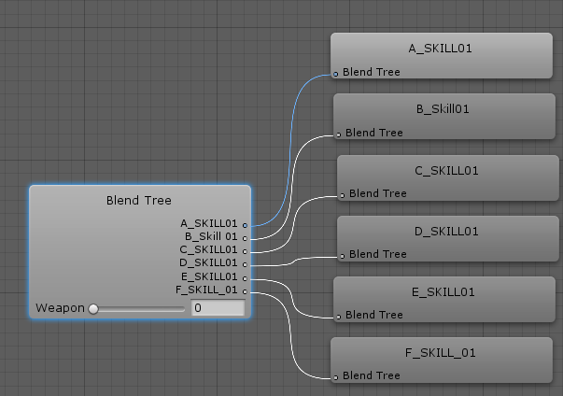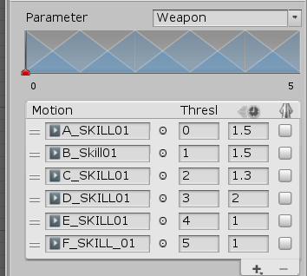

Rolling：direct roll controlled by shift+w/a/s/d ; and roll over by click twice a/s/d，

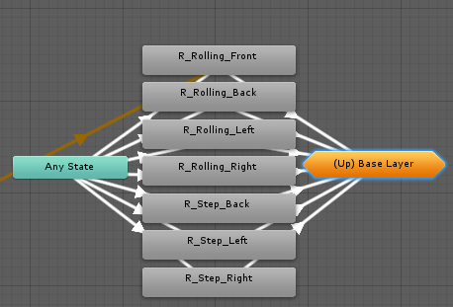

Grounded：

Ground state, movement, running, steering control,

different standby animations for different weapons

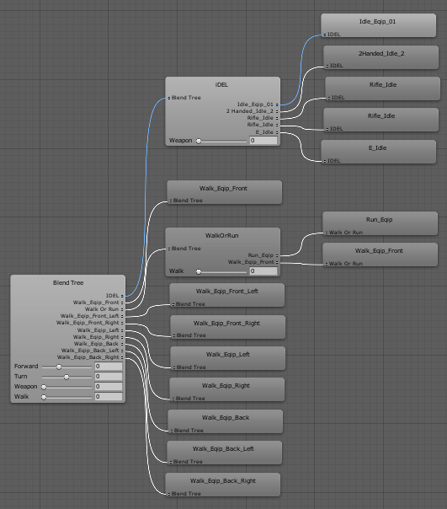

Animations for attacked

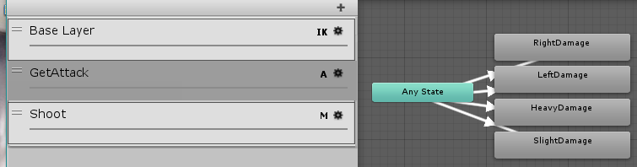

Override the basic animation

Shoot shooting layer，additional animation, mainly including “reloading” and “shooting”

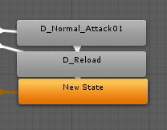

1. Move control

### 1.2.1 move, jump and air condition

This change is based on the third person controller that comes with the standard assets. The extra steering is removed. The ground judgment condition is changed to be the ray judgment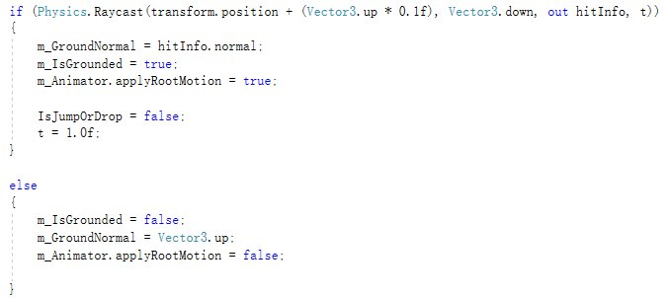

### 1.2.1 move control



1. WalkingSpeed, set with Forward parameter as smoothing coefficient *, is 0.707 when turning, that is, the speed of the hypotenuse of the right triangle

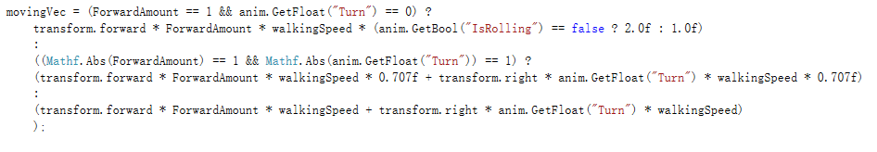

2. control the rigidbody

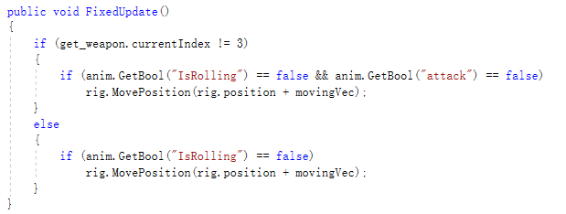

3. Attacks adsorption

When using a melee weapon and the target is within range, the character will rush to the enemy side

1. Normal atatck

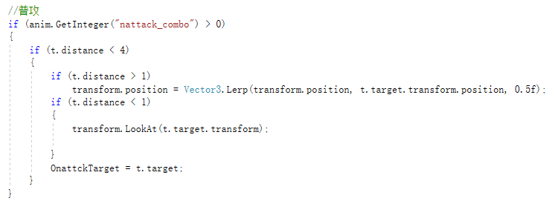

1. skill

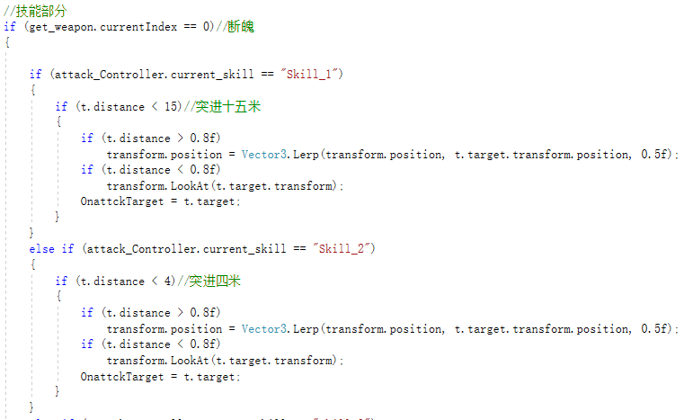

1. attack control

### 1.3.1combo



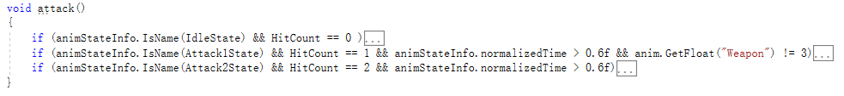

Hitcount represents the current combo status. A reattack during the period from 0.6f to 1.0f at the end of the current animation will result in a combo. Ranged weapons such as Flames and Machine Guns will not combo

### 1.3.2 skill release

 Button control; entering the combat state, will interrupt the current combo

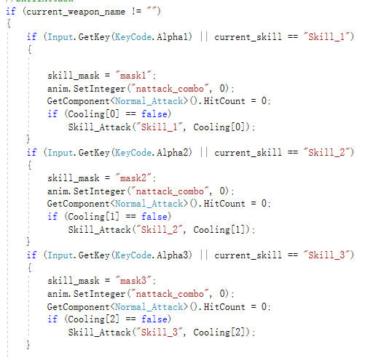

### 1.3.3 CD control



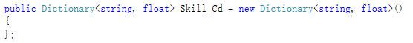

Creates a chilled bool array and a dictionary for CD

Assignments are also assigned to the cooldown of each skill by looking up the dictionary of the skill

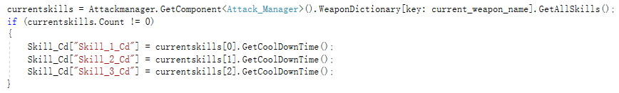

The cooling time is controlled in the UPDATE. Because the weapons will be replaced, the cooling needs to be removed at any time, so the iEnumerator coroutine is not used for control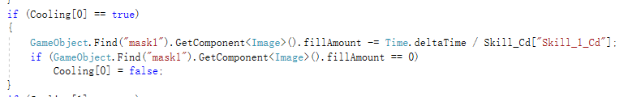

### 1.3.4 attack detection

#### 1.3.4.1 detection without props

Trigger detection is inserted into the animation frame to interact with all targets in the range of attack

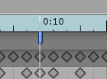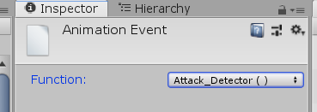

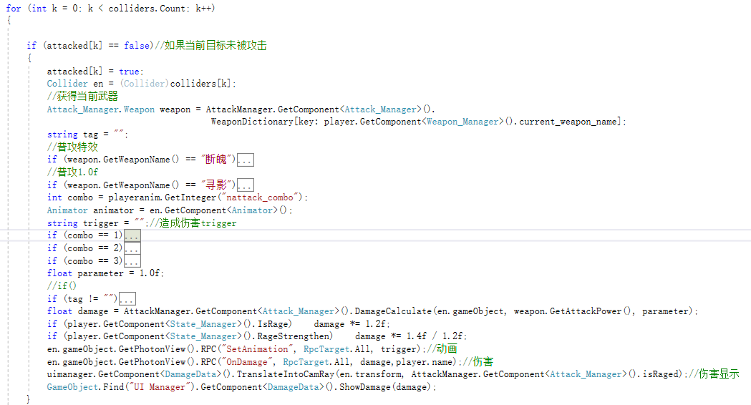

#### 1.3.4.2 detection with props

According to the trigger range of each item, fire a fire like a fire. Shot nine fire arrows, each of which will attack a single target once

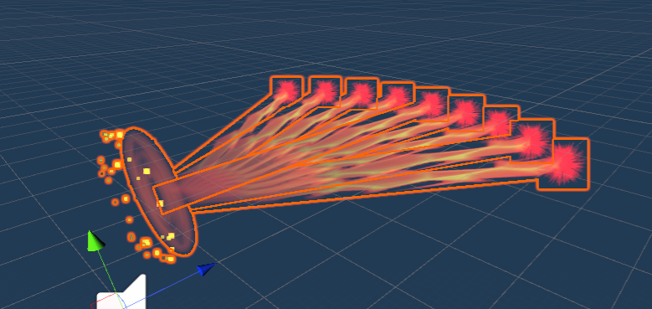

Judgment is made according to the Collision property of the particle system

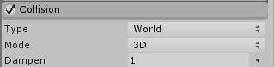

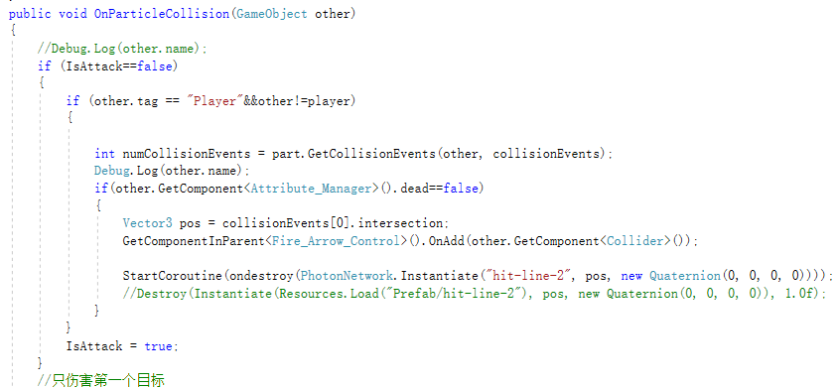

1. target choose



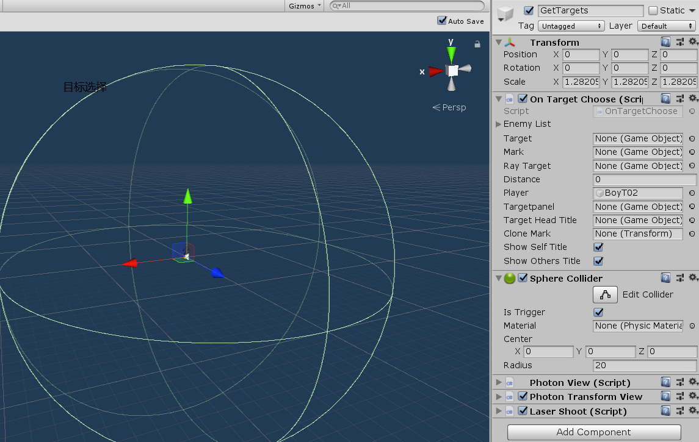

The range of target selection is 20 meters

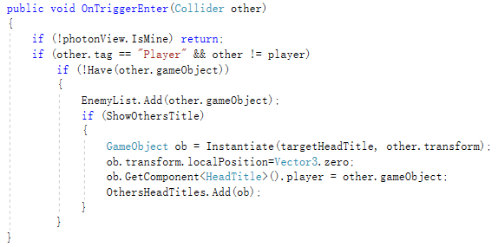

Show the information on the top of the player

Use trigger to control the enemy list within the range, enter the Enemy list first, if the player press Tab or mouse click, select the current target in the list, the ground aperture and property box display

Display the target after it is selected

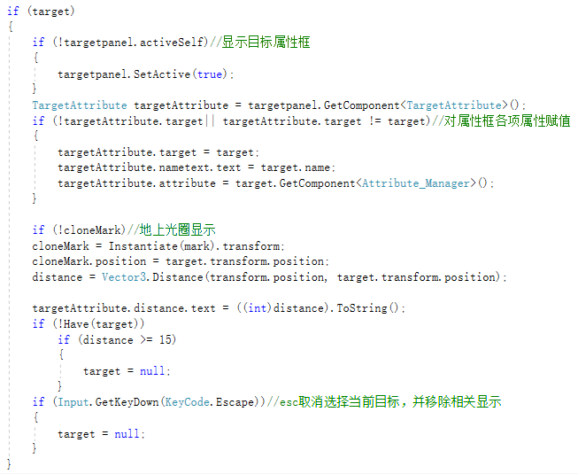

Mouse click to select target and display information

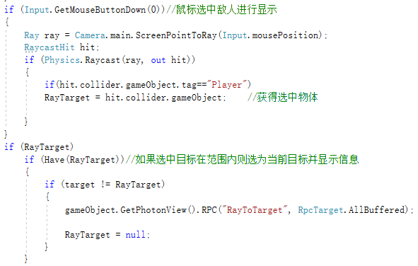

# attribute mangement



1. attribute types

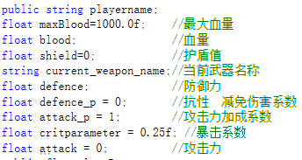

1. damage control

OnDmage

1. damage<0 The function performs the health return
2. 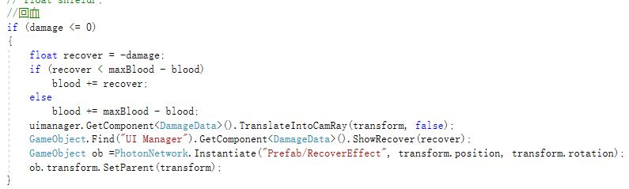

2. The specific damage taken will be affected by the value of the shield and special abilities

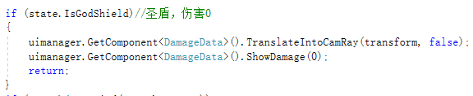

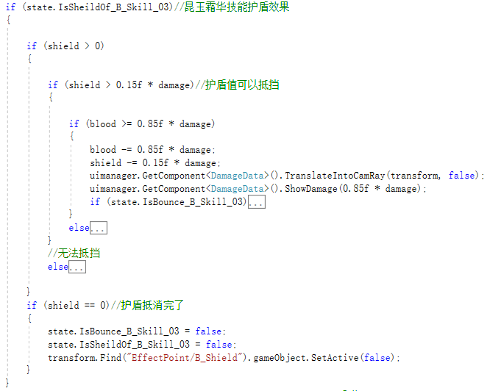

1. Kill and death notification

Through PunRPC

Poisoned to death by a poison ring or by poisoned water →die an unnatural death

And reports kills between characters

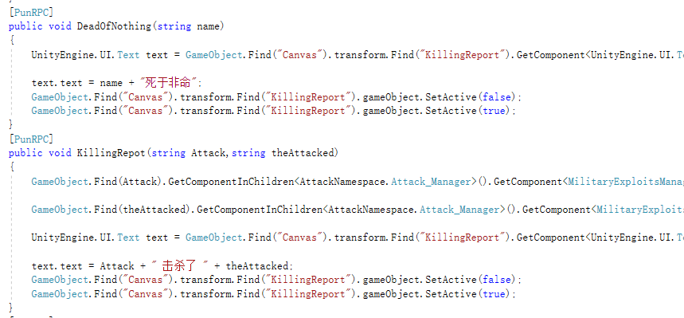

# Weapons management

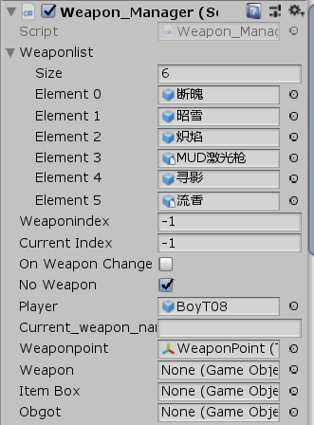 

1. Weapon switch

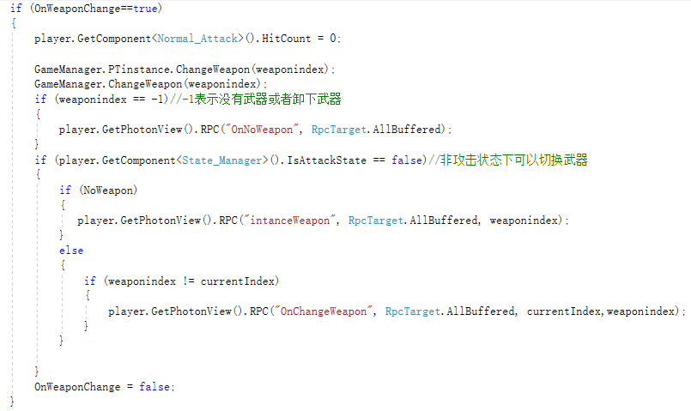

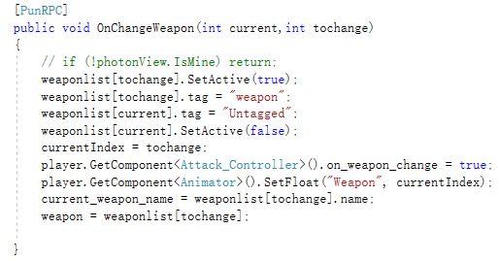

The weapon is first bound to the character. It starts as Unable and switches when it is picked up

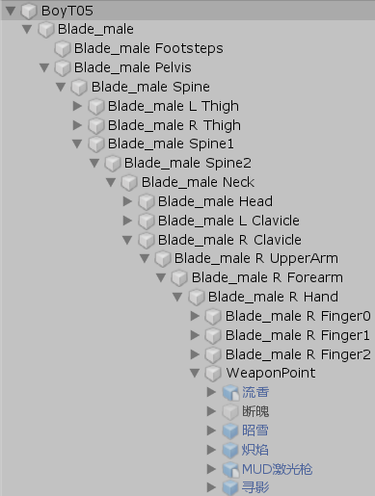

1. Weapon acquire

The weapon box is a red ball of light

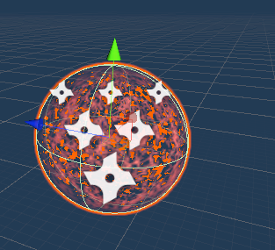

Use the tag “itembox” to control

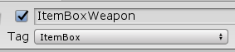

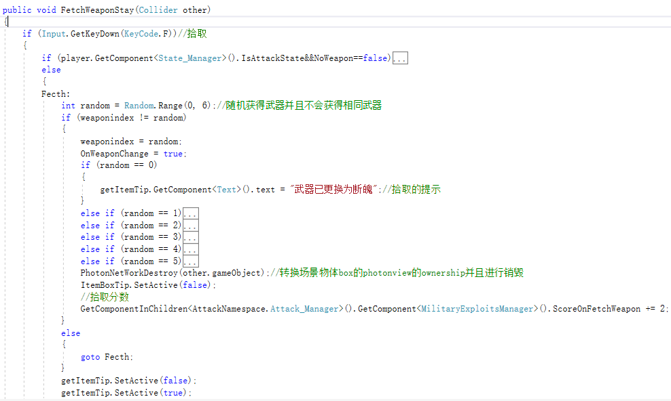

# State control

1. State types

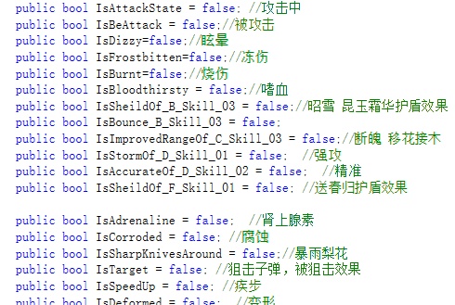

A total of 26 character states, including weapon skills and generic skills, are managed using bool types

State process

Most states are controlled using coroutines

Take off the war

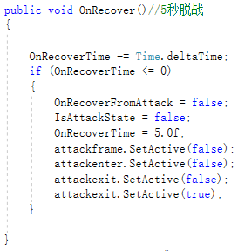

Example of a versatile skill: adrenaline

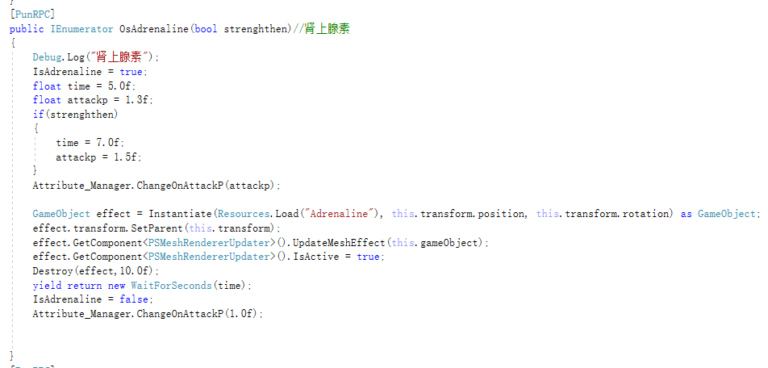

First aid, health is already synchronized in the properties, so RPC is not needed here

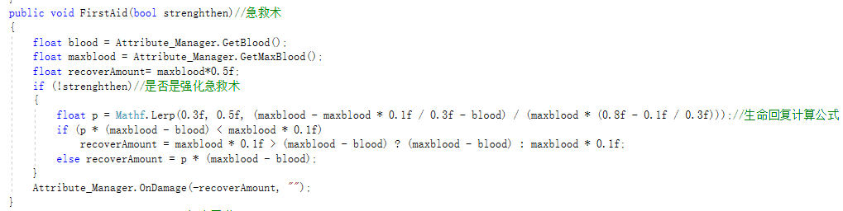

# Skill implementation

1. Normal attack

Melee weapon general attack, using the above - mentioned combo production

Attack with long-range weapons

1. blazing

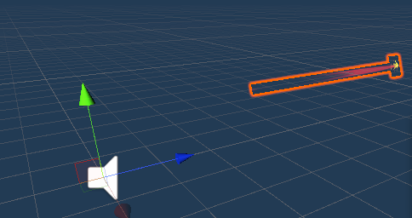 

1. flowering fragrance: generate attack props, and set up props animation, through its own collider for attack detection

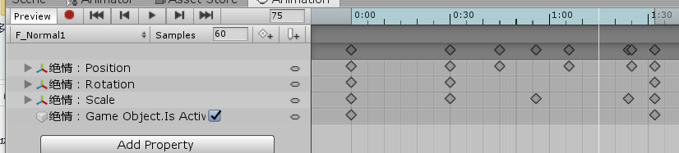

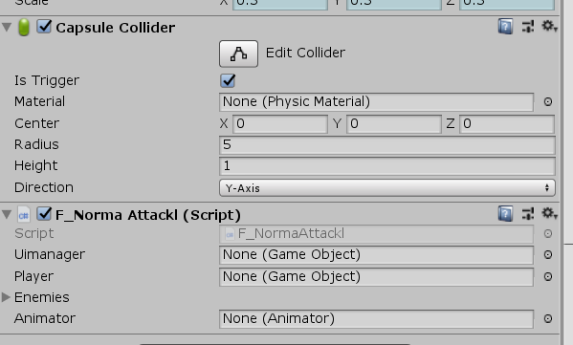



1. mud laser gun

Similar to 2, it also generates items, detected by its own collider

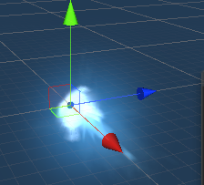

1. weapon skills

Part of the special mechanism description

1. Blazing 1st ability. Detect the attack of each bolt. Attack the same target by gathering them together



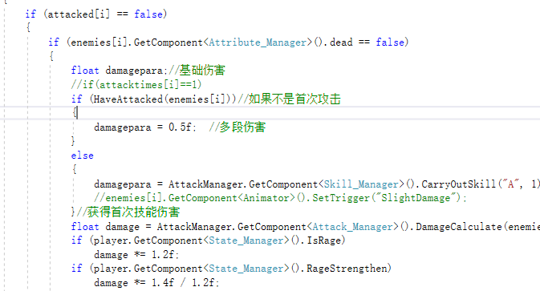

1. Blazing 2nd skill, Tracking skill, after the target is selected, set the target level to the particle collision level, and then change the displacement of each particle to attack

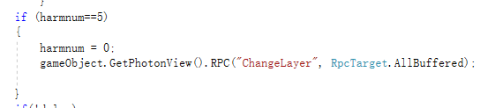

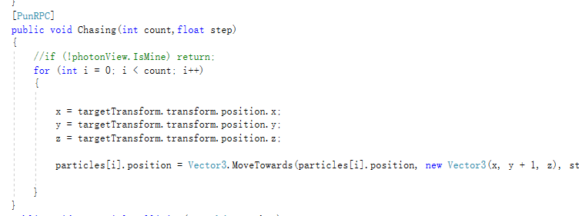

1. Snow 2nd ability, ice and snow, change the target’s shader with frostbite effect

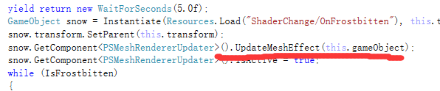

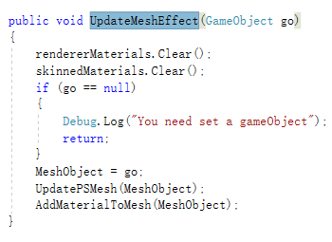

1. Flowering fragrance 1st ability bounces, actually dealing damage to the target

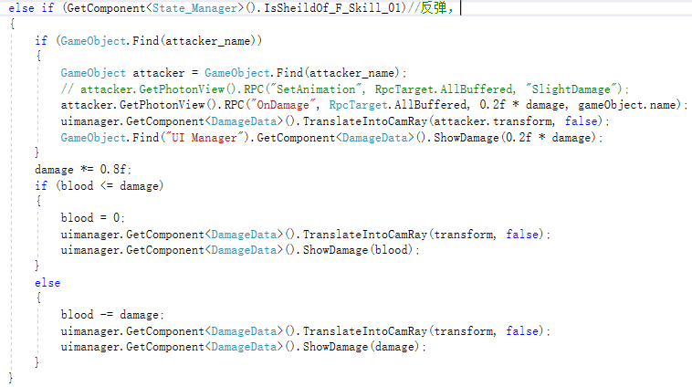

1. Skill effects display, are generated by the way of prefab，

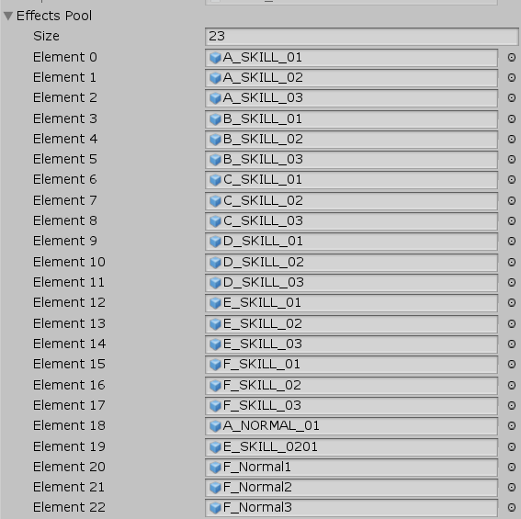

1. Common skills
2. Shape skill. Hide the target's mesh. Generate shaped objects under the target child

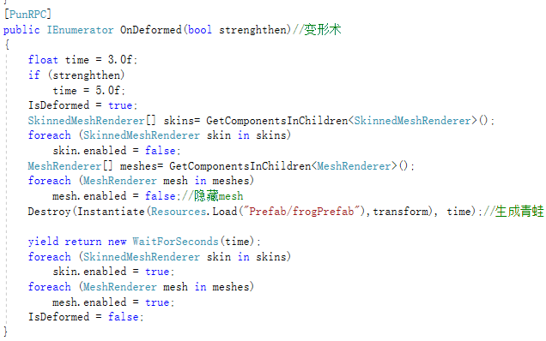

1. Sniper bullets, the target locking skill, also change the displacement of the object towards the target to attack

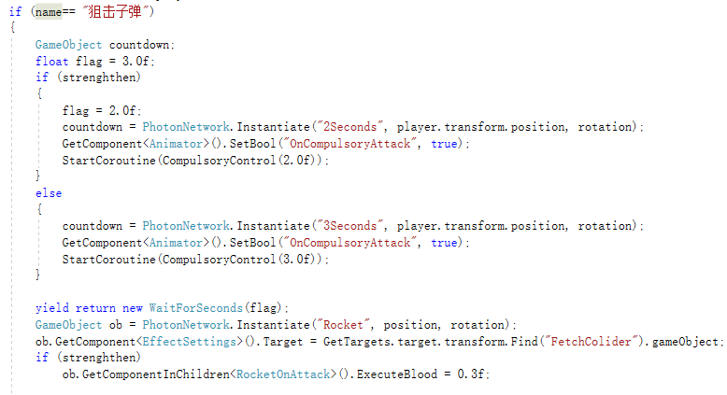

1. State skills, using coroutine processing, change role properties during coroutine

For example ：petrification

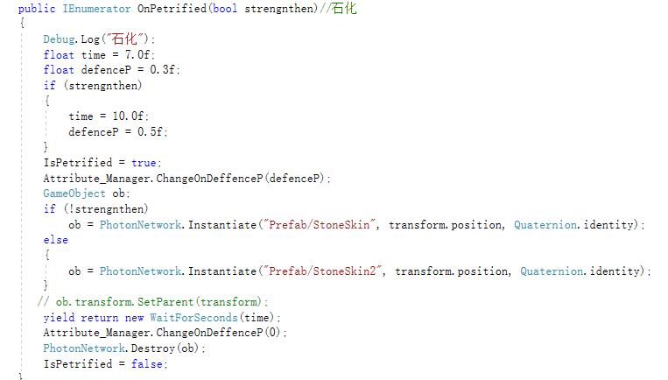

1. Skills overall

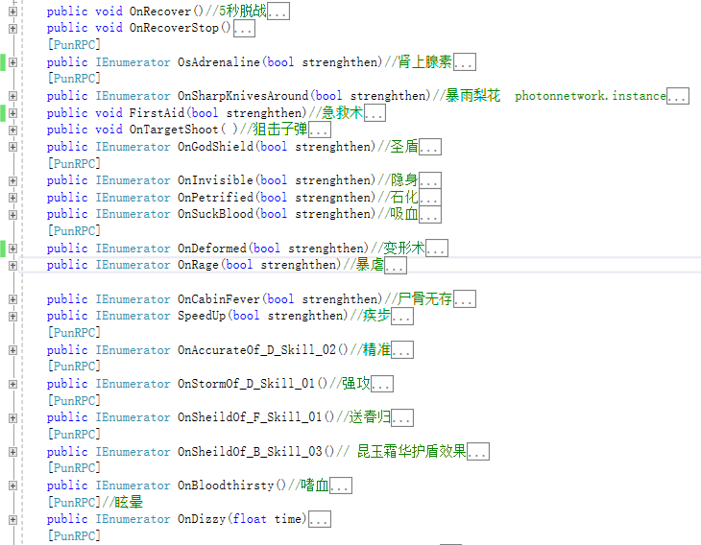

1. Skill backpack



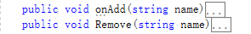

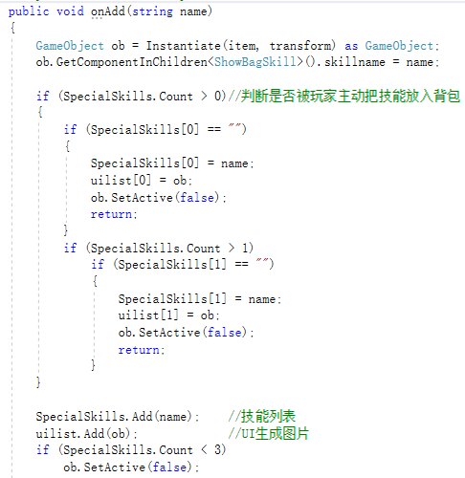

1. Effects making

Most of them are self-made, and a few of the overly complicated special effects, such as shader writing, are not self-made, mainly using particle effects and animation system

1. Ice cut

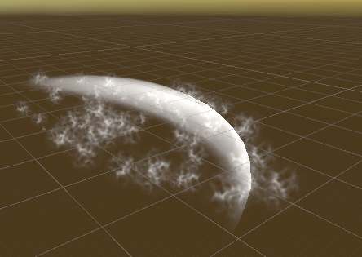

particles

Apply a transparent texture map

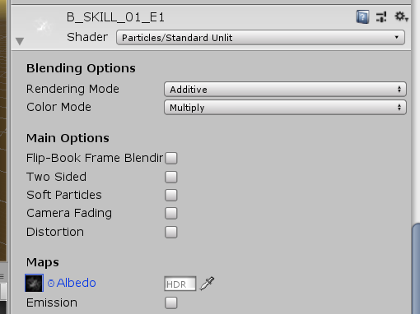

Change the properties of the particle system

Change the size

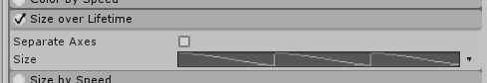

Shape

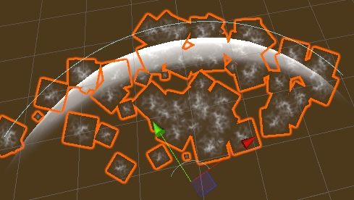

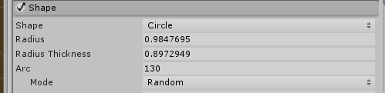

offset

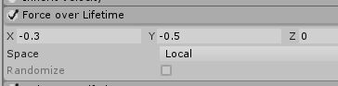

1. Slash glow

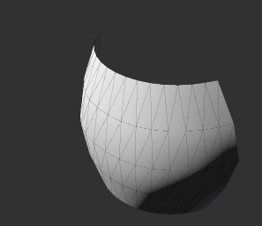

Model the blade shape and edit the UV

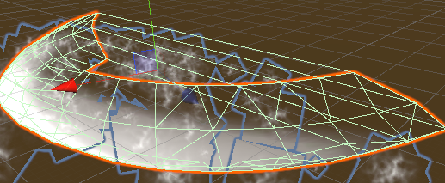

Add the material

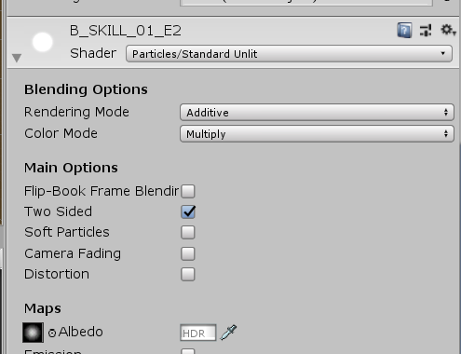

Using animation to change the UV and accomplish the effect

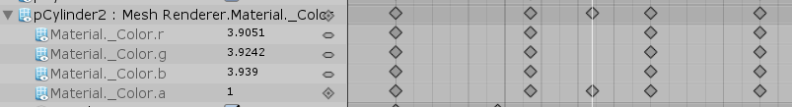

1. Ice and snow

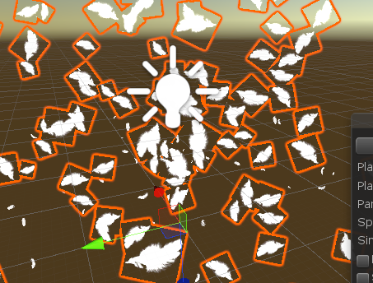

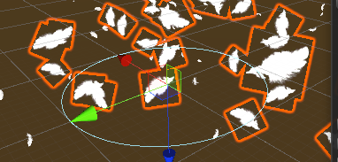

Feather particles are formed by spiraling up from the ground

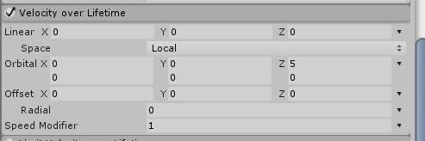

二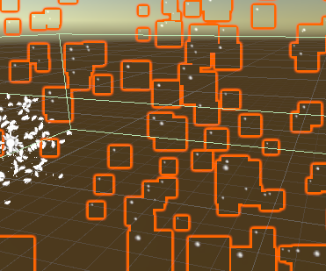

The material is segmented to show snowflakes of different sizes and shapes

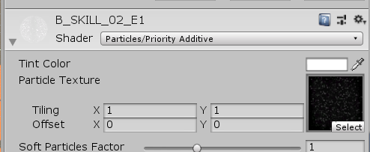

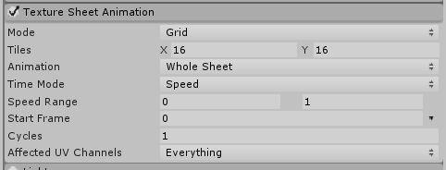

Control generating snow on the ground with the ground collision function (compare consumption performance)

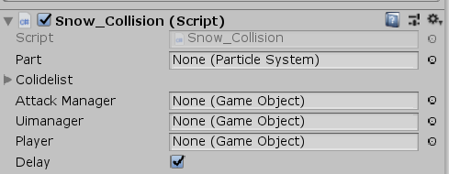

1. Flowering fragrance 2nd skill

first section is designed as a tornado type

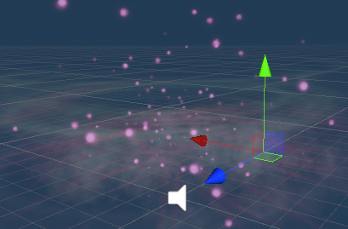

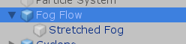

Fog and Particle

Two-section Flat Fog Particle Effects

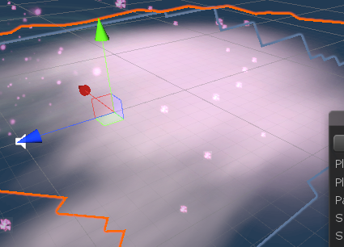

Attack detection uses animation to control the synchronization of BoxColider and weapon movement

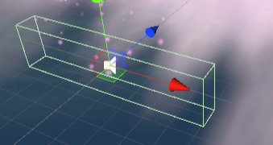

Too many skills, not a full display here

# Scene management

1. Props generation

 controlled by Masterclient

The item spawning locations are laid out in advance, with 30 item spawning points per map

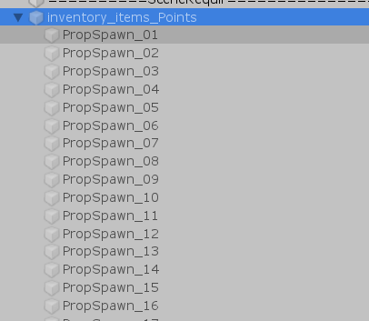 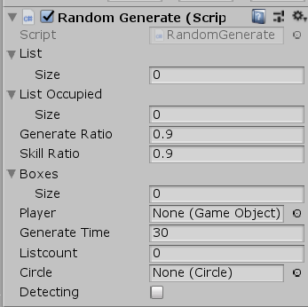

Build at a preset build scale

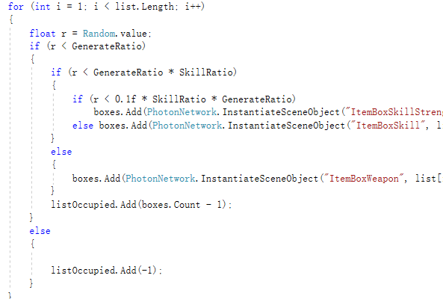

Item detection and generation are carried out in each period, and the items are filled proportionally

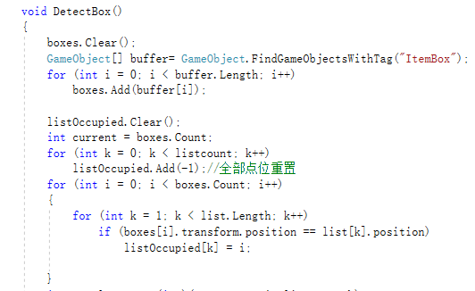

1. Circle control

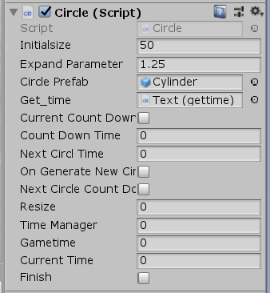

Set the timer of the current poison circle and the countdown to the next poison circle. After the poison circle is generated, the poison circle itself expands



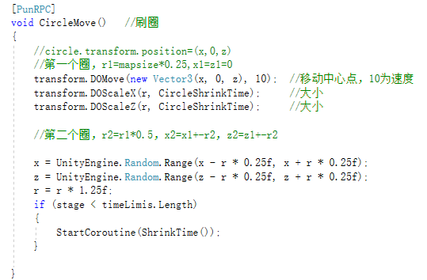

1. Player birth place

Set up 10 random spawn points per map, start or resurrect for random spawn

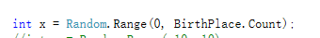



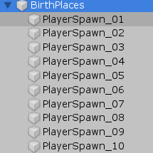

# Time synchronization

7.1game time

Time is timed by MasterClient and synchronized to other clients via RPC

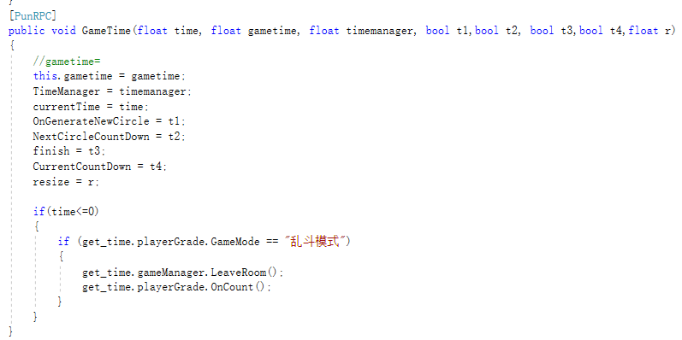

7.2 circle time

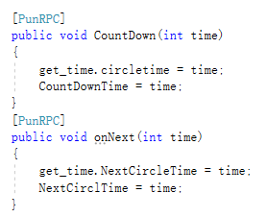

# Data management

* 1. Data synchronization

RPC and IPunObservable

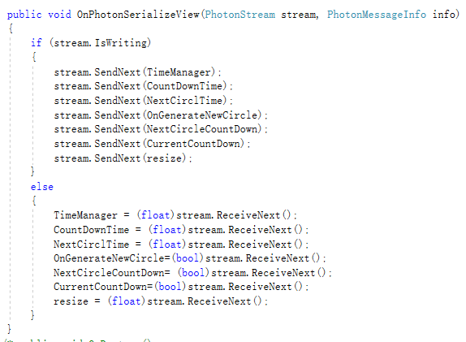

# UI design and implementation

Most of them are made through UGUI to make UI animation, and at the same time, post processing is used to achieve flood light effect and optimize the picture. The overall tone is white, with black, white and gray as the main colors. Meanwhile, most of them are transparent, simple and refreshing

9.1 lobby

### 9.1.1 login

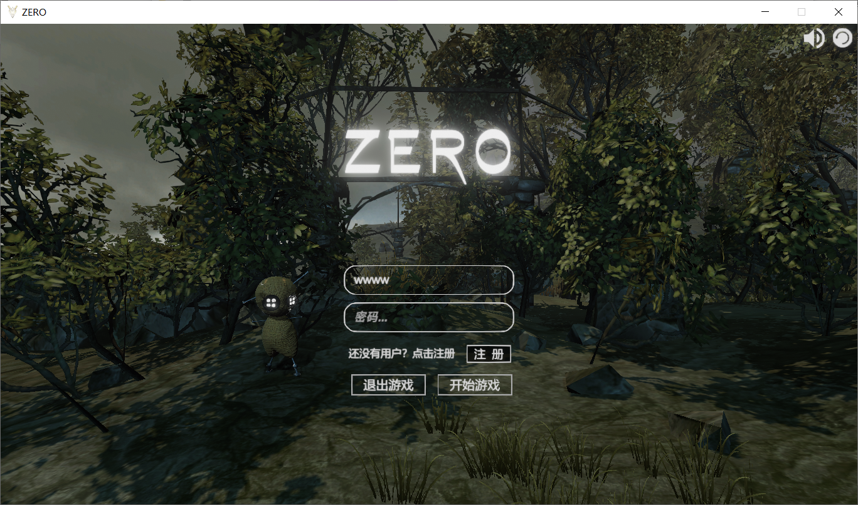

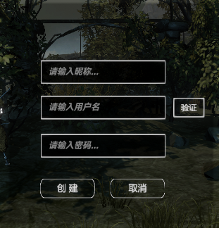

### 9.1.2room list

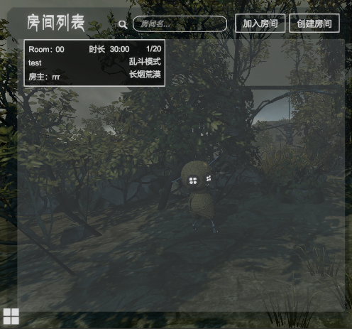打开

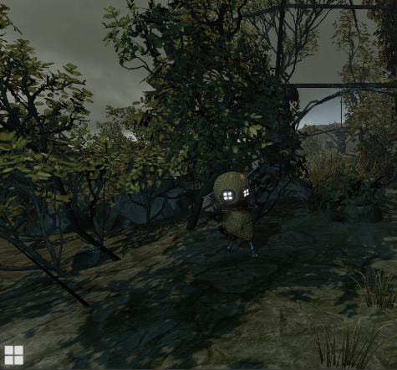

### 9.1.3 create room

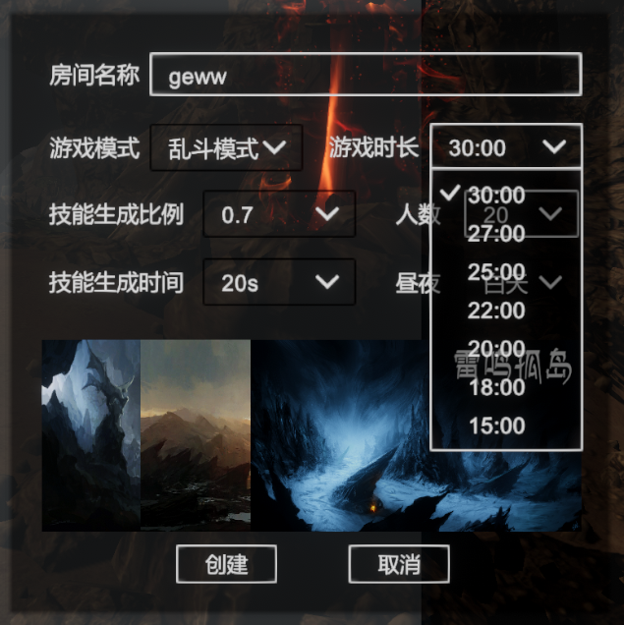

### 9.1.4 record

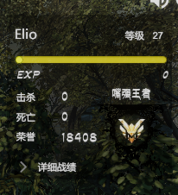 close→open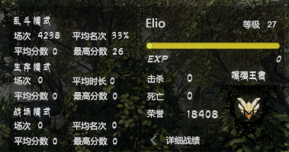

### 9.1.5 setting

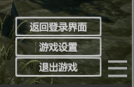 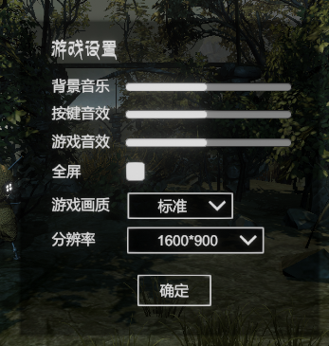

Picture quality control and resolution control



### 9.1.5界面背景

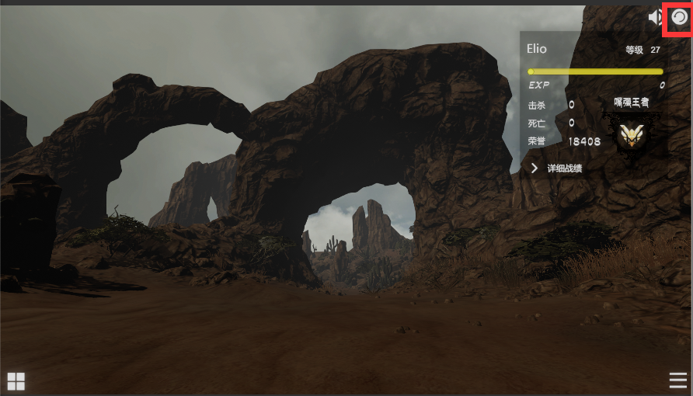

The upper right button can refresh and change the background

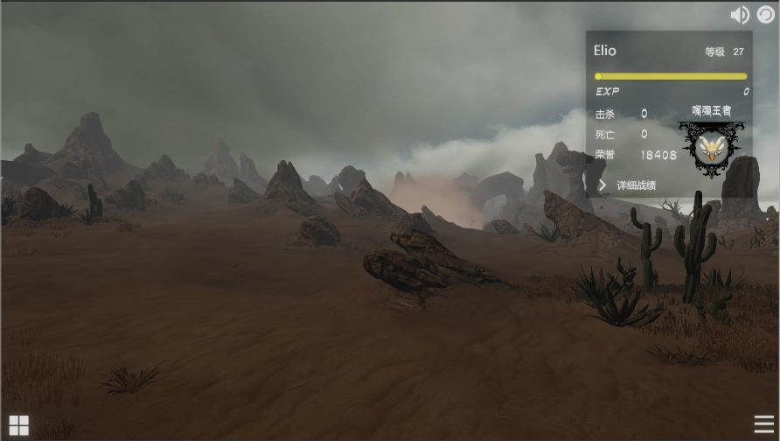

Different cameras and scene displays are used to achieve a 3D background effect

### 9.1.6 loading

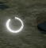

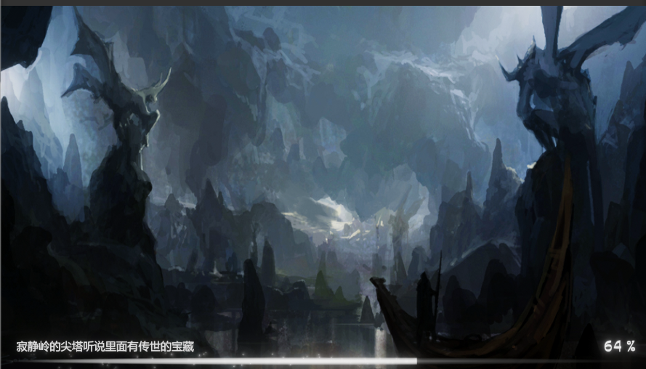

The game loads, makes use of particle effects to make sliders, loads asynchronously, and has various tips

9.2 game interface

### 9.2.1 skill and backpack

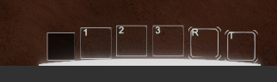

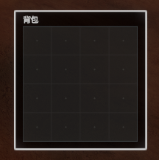 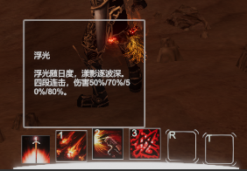

### 9.2.2 attribute

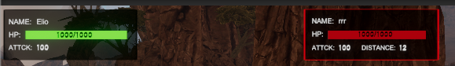

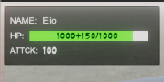

Shields are represented by a white bar

The upper part of the interface displays self and enemy properties, and the enemy properties include the distance display

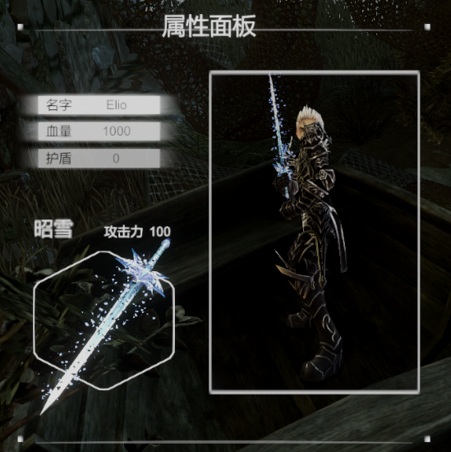

Use the render texture and camera to make 3D interface

### 9.2.3 panel on the top of head

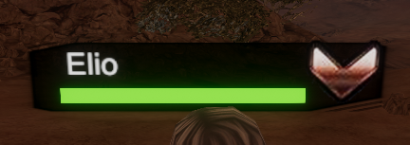

Name, health and level

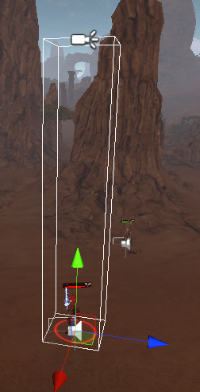

### 9.2.4light circle underfoot

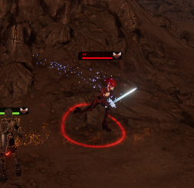

Projection is used to display the aperture, which can fit the ground

### 9.2.5 ranking list

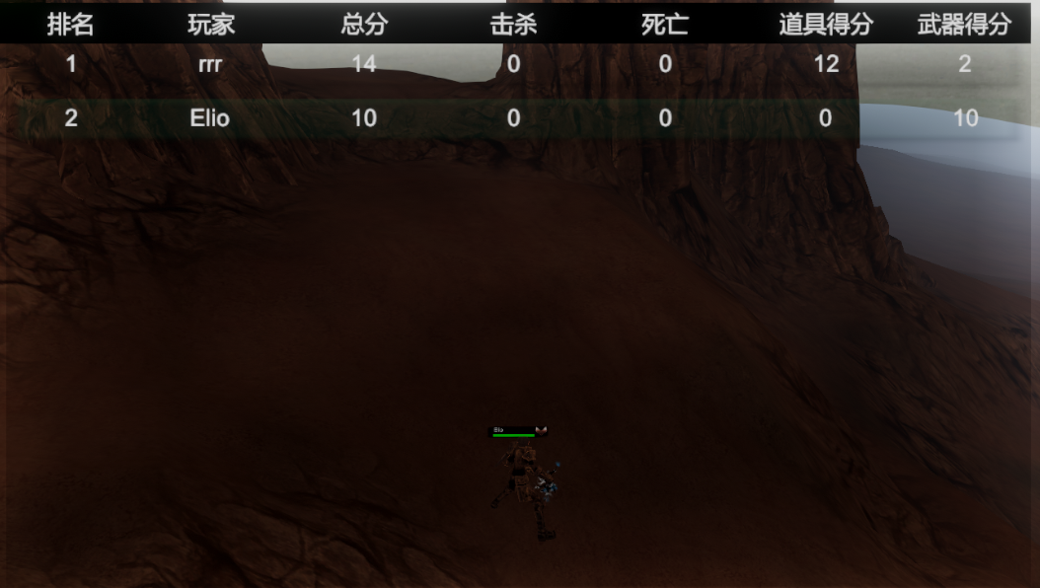

### 9.2.6tip

In battle, the entire game border will turn red and flash slightly

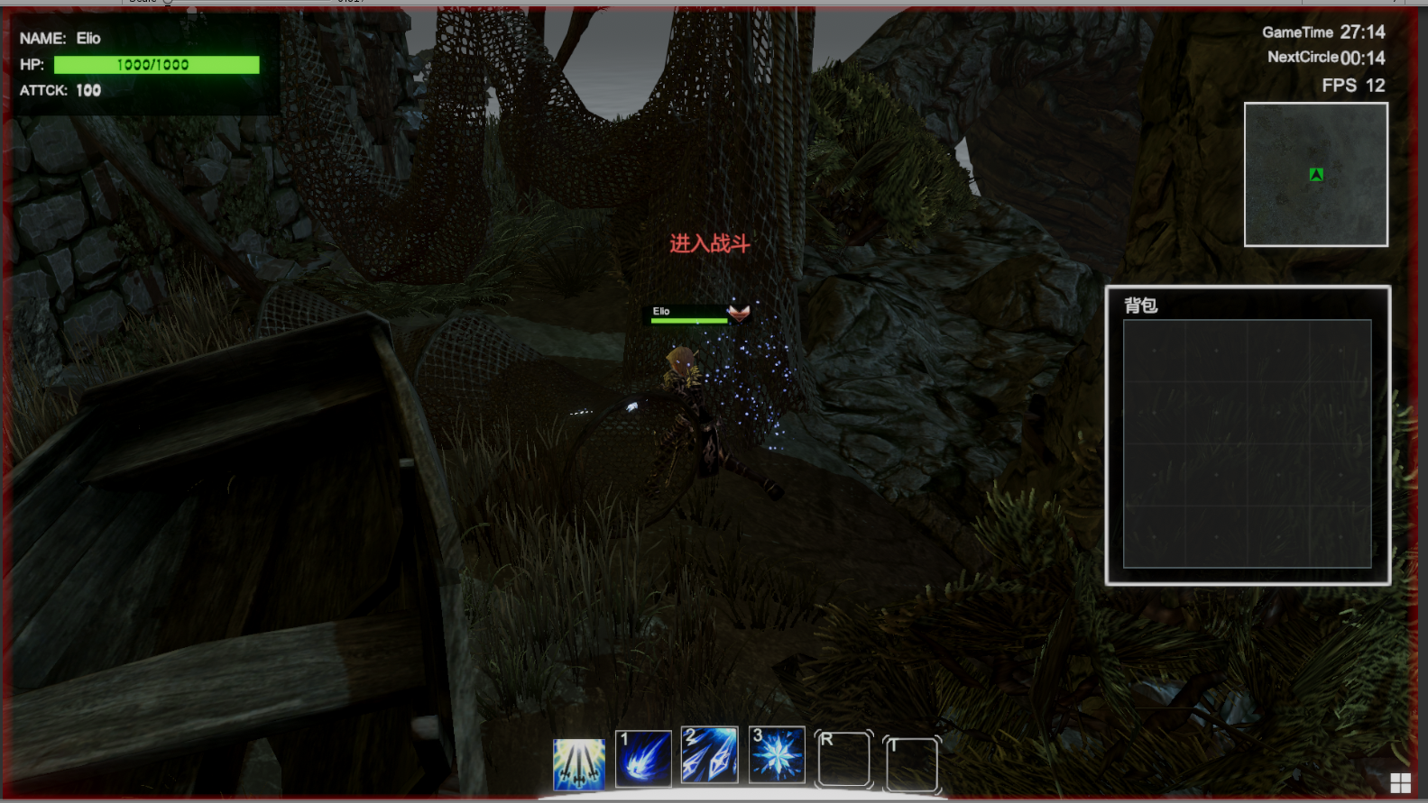

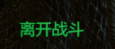

There will be hints for picking up items

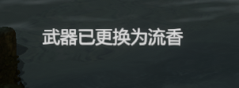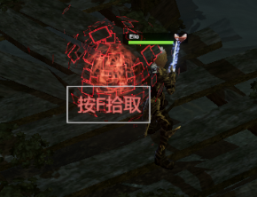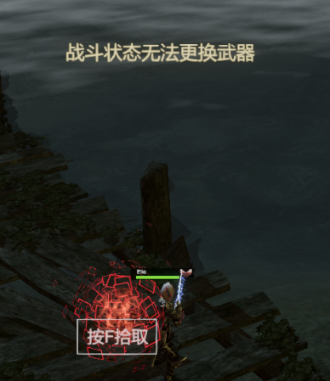

### 9.2.7 Timing frame count minimap in upper right corner

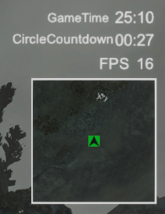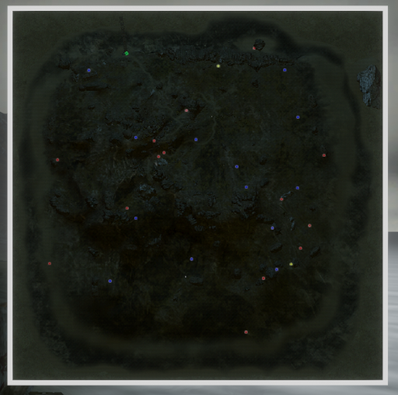

### 9.2.6 evaluating interface

